标题：Selling Bonus Actions in Video Games
作者及机构:
Lifei Sheng: Department of Decision Science, University of Houston–Clear Lake, Houston, Texas 77058
Xuying Zhao: Department of Information and Operations Management, Texas A&M University, College Station, Texas 77843
Christopher Thomas Ryan: Operations and Logistics Division, The University of British Columbia, Vancouver, British Columbia V6T 1Z2, Canada
摘要: In the mobile video games industry, a common in-app purchase is for additional “moves” or “time” in single-player puzzle games. We call these in-app purchasesbonus actions. In some games, bonus actions can only be purchased in advance of attempting a level of the game (pure advance sales (PAS)), yet in other games, bonus actions can only be purchased in a “spot” market that appears when an initial attempt to pass the level fails (pure spot sales). Some games offer both advance and spot purchases (hybrid advance sales). This paper studies these selling strategies for bonus actions in video games. Such a question is novel to in-app tools selling in video games, and it cannot be answered by previous advance selling studies focusing on end goods. We model the selling of bonus actions as a stochastic extensive form game. We show how the distribution of skill among players (i.e., their inherent ability to pass the level) and the inherent randomness of the game influence selling strategies. For casual games, where low-skill players have a sufficiently high probability of success in each attempt, if the proportion of high-skill players is either sufficiently large or sufficiently small, firms should adopt PAS and shut down the “spot” market. Furthermore, the player welfare-maximizing selling strategy is to sell only in the spot market. Hence, no “win-win” strategy exists for casual games. However, PAS can be a win-win for hardcore games, where low-skill players have a sufficiently low success probability for each attempt.
AI标题: 游戏熵值驱动定价革命：硬核休闲双轨策略解密
AI精炼: 该论文聚焦移动单机解谜类游戏中的内购工具（如额外步数/时间）销售策略，属于运营管理与数字产品定价交叉领域。研究核心在于如何通过时间维度（提前销售、即时销售或混合销售）最大化游戏公司收益，这一议题在传统终端商品定价研究中缺乏针对性解决方案。作者创新性地构建了包含技能差异（高/低水平玩家）与游戏随机性（关卡熵值）的随机扩展博弈模型，首次将工具型商品的"三层不确定性"（需求、效用、使用结果）引入分析框架。研究发现：对于低难度休闲游戏，当高技能玩家占比极端（极高或极低）时，应关闭即时市场仅采用提前销售；而中等玩家分布时需混合策略。对于高难度硬核游戏，提前销售始终最优且能实现玩家与公司双赢。研究突破了传统定价理论仅关注终端商品的局限，揭示了游戏机制设计（如随机性调节）与玩家技能结构对盈利策略的复杂交互影响，为动态调整游戏内购策略提供了量化依据。
关键词:
随机扩展博弈模型
工具型商品三层不确定性
玩家技能分布建模
熵值驱动定价策略
混合销售策略优化
双轨定价机制
福利最大化策略分析
动态博弈均衡解
学术要点: 学术要点 1：工具性商品与终端商品区分（Tools vs. End Goods） 论文首次提出游戏内"奖励动作"属于工具性商品（Means），其价值取决于使用时的场景状态，与终端商品（Ends）的价值实现路径存在根本差异。|||
学术要点 2：随机扩展形式博弈模型（Stochastic Extensive Form Game） 构建包含三层不确定性的博弈模型：工具需求不确定性、工具使用效果不确定性和使用结果不确定性，突破传统提前销售研究的单层不确定性框架。|||
学术要点 3：技能异质性阈值效应（Skill Heterogeneity Threshold） 高技能与低技能玩家比例存在两个临界阈值，当市场结构突破阈值时最优策略发生突变，呈现非单调决策特征。|||
学术要点 4：游戏熵（Game Entropy） 通过δ参数量化关卡设计的随机性程度，揭示随机性水平与提前销售策略选择的倒U型关系，建立可操作化的游戏设计指标。|||
学术要点 5：玩家福利悖论（Player Welfare Paradox） 发现盈利最大化策略与玩家福利最大化策略必然背离的"零和"现象，提出仅硬核游戏可实现双赢的特殊条件。
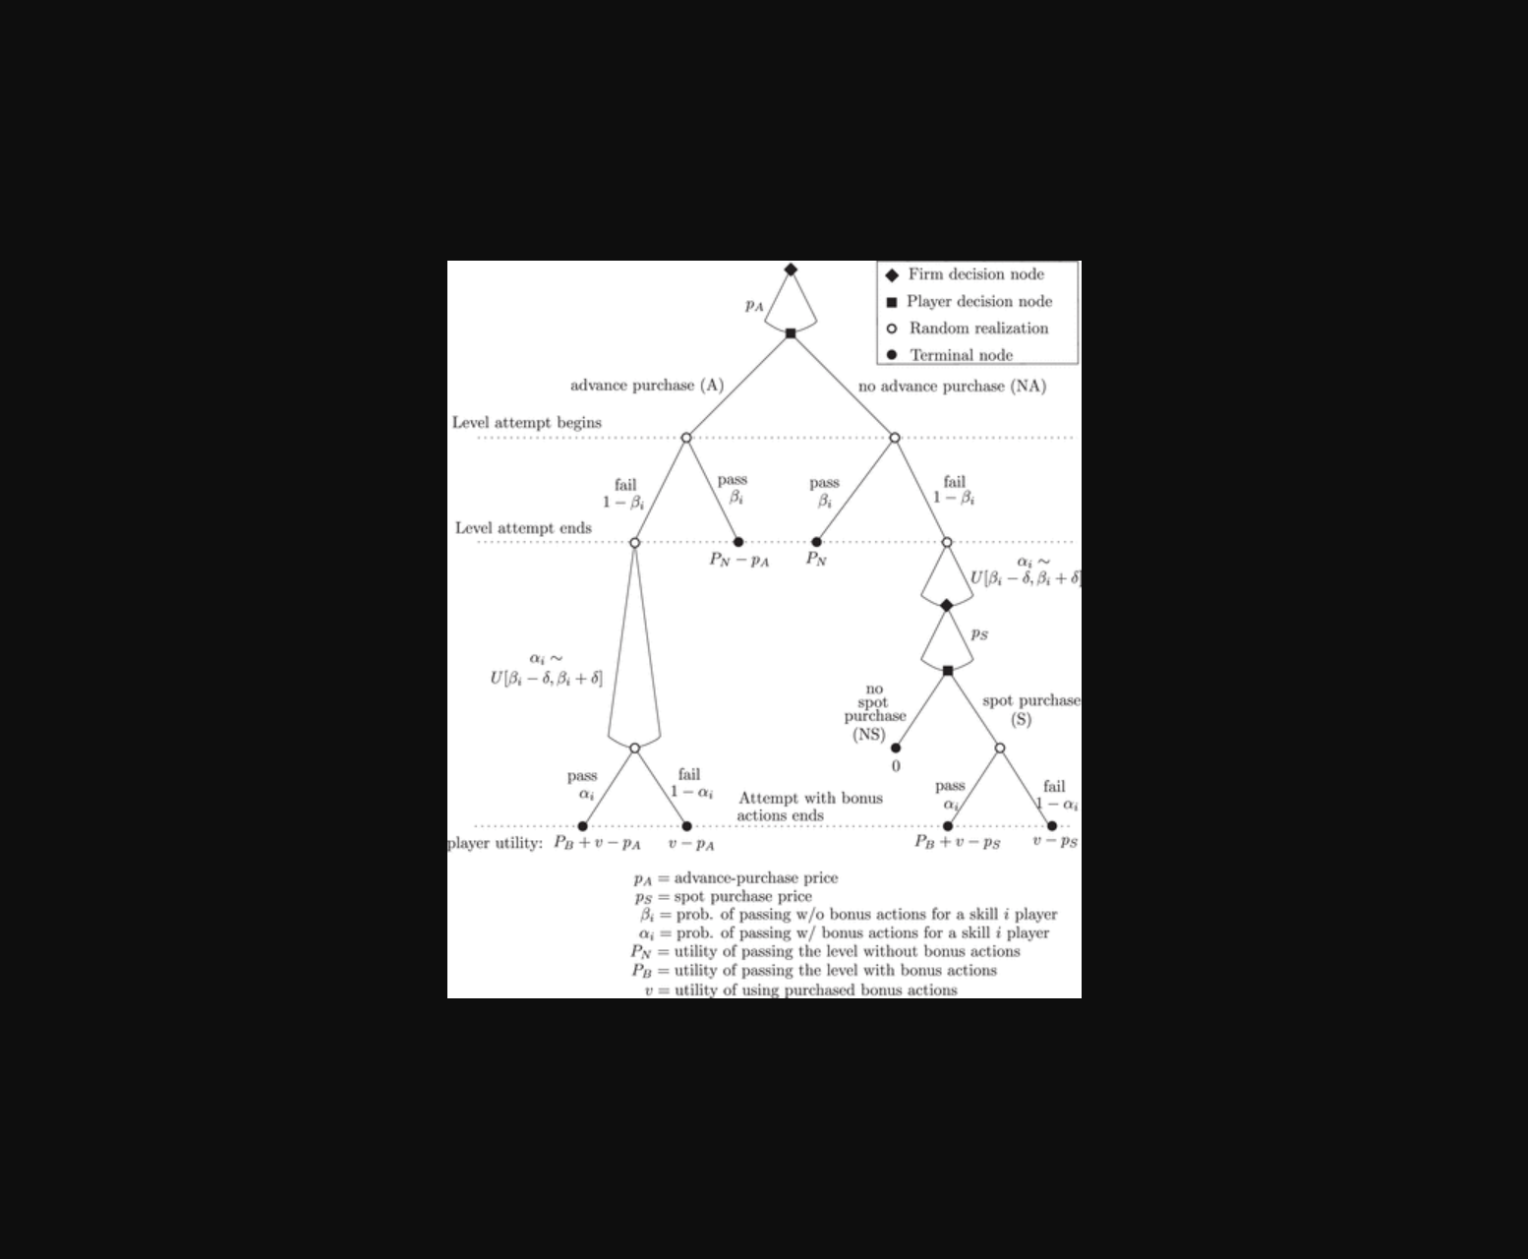
该图展示了不同销售策略下玩家技能分布与购买决策的博弈模型结构。
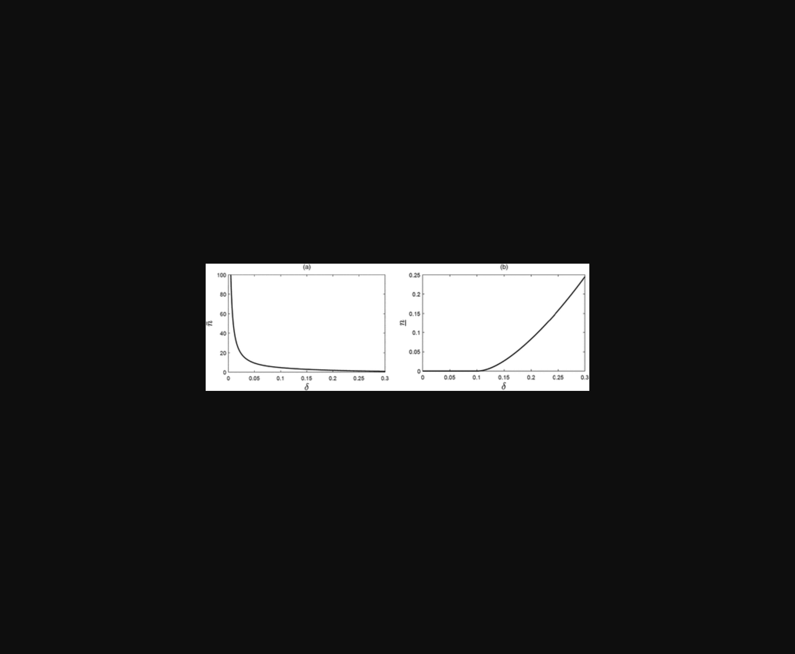
图示不同销售策略下企业收益与玩家购买行为的对比。
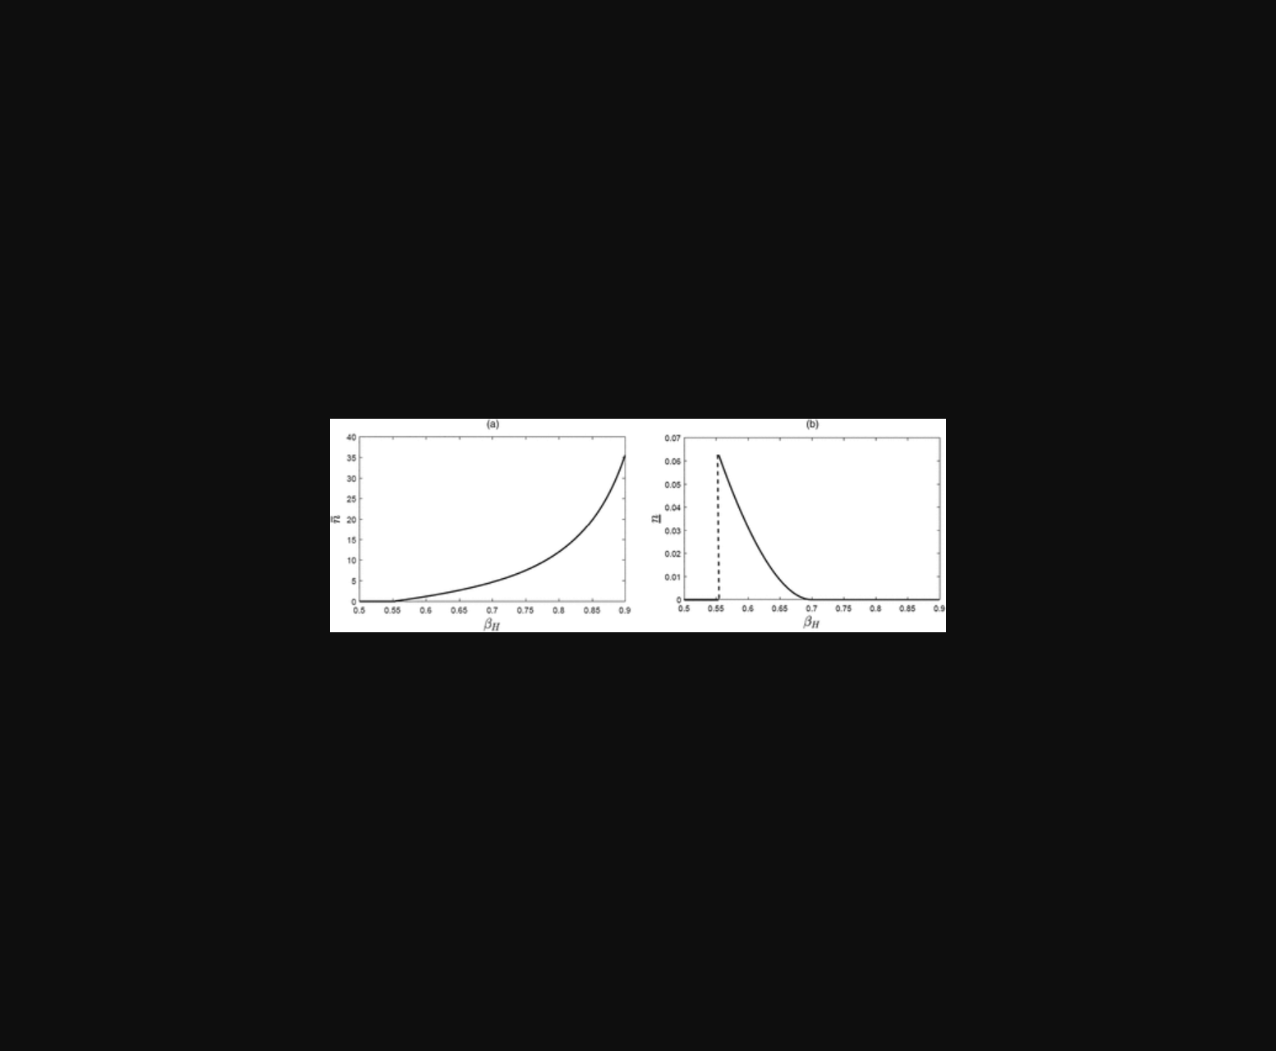
该图展示了玩家技能分布与不同销售策略（提前/即时/混合）下游戏收益的对比分析模型。
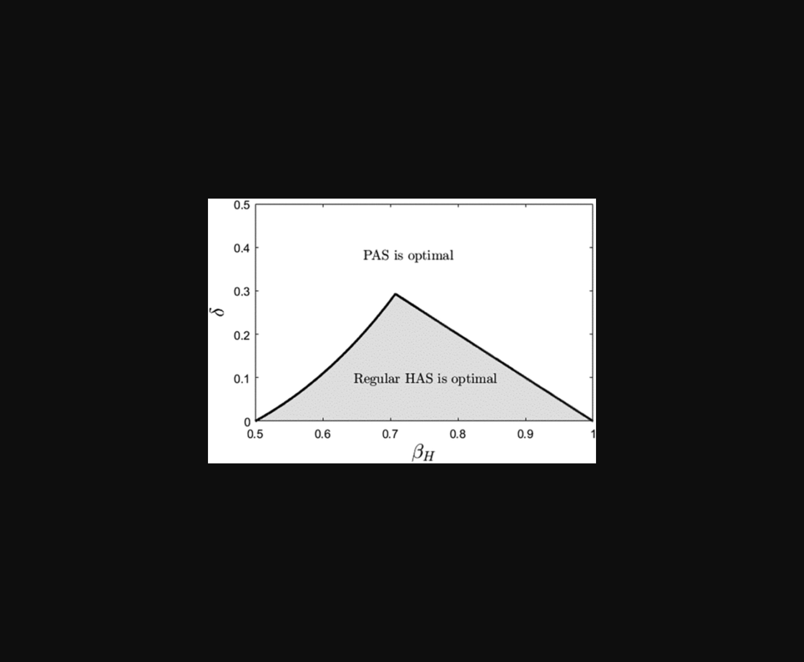
该图呈现了不同销售策略下玩家技能分布与购买行为的博弈模型对比。
原文链接: https://doi.org/10.1287/mnsc.2022.02348

